

**Faculty of Engineering & Technology Electrical and Computer Engineering Department**

**Communications Laboratory Report #3:**

**Experiment No 11. Frequency and Phase Shift Keying**

|  |  |
| --- | --- |
| **Prepared by:** |  |
| Arwa Doha | 1190324 |
| **Partners:** |  |
| Hamza Awashra | 1201619 |
| Saleh Zhour | 1201941 |

**Instructor:** Dr.Ashraf Al-Rimwi **Assistant:** Mohammad Al-Battat **Section:** 6

**Date:** December 2, 2023

# Abstract

The-aim of-this-experiment-is-to-understand-digital-communication-systems, specifically frequency-and-phase-shift-keying. We experiment with-two-types-of keying-known as the soft and hard-keying. Moreover, we show the modulation and-demodulation of-signals in-both the frequency-domain-and time-domain and discuss-the results-in-comparison-with-the-theoretical part. We-discuss-the-importance of-various-mathematical-equations such as the-probability-of-error and the-energy of-different-signals that are used-in frequency and-phase-shift keying.

# Table of Contents

1. **Abstract** I
2. [**Theory**](https://docs.google.com/document/d/1bJtlnOT_Cf2HDBLa6Q0fTgGsQyMr-ABqseQClZ0zYYQ/edit#heading%3Dh.dmshv0kvip70)
   * 2.1 Frequency and*Shift*Keying*Modulation 1
   * 2.2 Frequency and Phase/Shift/Keying/Demodulation 3
3. [Procedure and D](https://docs.google.com/document/d/1bJtlnOT_Cf2HDBLa6Q0fTgGsQyMr-ABqseQClZ0zYYQ/edit#heading%3Dh.i5b9td577uci)ata Analysis
   * 3.1 Frequency shift*keying*Modulation 4
   * 3.2 Frequency shift*keying*Demodulation 14
   * 3.3 Phase shift*keying*Modulation 18

- 3.3 Phase shift*keying*Demodulation 24

[Conclusion](https://docs.google.com/document/d/1bJtlnOT_Cf2HDBLa6Q0fTgGsQyMr-ABqseQClZ0zYYQ/edit#heading%3Dh.2ajmbri2k2qt) 29

[References](https://docs.google.com/document/d/1bJtlnOT_Cf2HDBLa6Q0fTgGsQyMr-ABqseQClZ0zYYQ/edit#heading%3Dh.rb1nryd0zcyc) 30

# Table of Figures

* Figure 1: Digital*Communication*System 1
* Figure 2: Frequency/Shift/Keying/Modulated output wave 2
* Figure 3: Phase/Shift/Keying/Modulated output wave 2
* Figure 4: Frequency/Shift/Keying Setup 4
* Figure 5: Modulating signal and/Unipolar square/wave signal(Hard Keying) 4
* Figure 6: Modulating/signal and/Unipolar/square wave/signal in/Frequency/Domain 5
* Figure 7: Unipolar square/wave signal and Modulated/Signal 7
* Figure 8: Unipolar square/wave signal and Modulated/Signal in Frequency/Domain 6
* Figure 9: Modulating/signal and Unipolar/square wave/signal(Soft Keying) 7
* Figure 10: Modulating/signal and Unipolar/square wave/signal in/Frequency

Domain(Soft Keying) 7

* Figure 11: Unipolar/square wave signal/and Modulated/Signal(Soft Keying) 8
* Figure 12: Unipolar/square wave signal/and Modulated/Signal in/Frequency/Domain (Soft Keying) 8
* Figure 13: Signal sent/at binary/value 0, with/frequency/15khz 9
* Figure 14: Unipolar/signal and/Frequency Shift/Keying/signal/with fm=500hz 10
* Figure 15: Unipolar/signal and/Frequency/Shift Keying signal/with fm=500 hz in Frequency Domain 10
* Figure 16: Signals/with/duty/cycle 10% 11
* Figure 17: Signals/with/duty/cycle 10% in Frequency/Domain 12
* Figure 18: Signals/with/duty/cycle 50% 12
* Figure 19: Signals with/duty/cycle 50% in/frequency/Domain 13
* Figure 20: Frequency Shift/Keying/Demodulation/Setup 14
* Figure 21: Bipolar/message and demodulated/signals in/Time Domain (Hard keying) 15
* Figure 22: Bipolar/message and demodulated/signals in/Frequency Domain (Hard keying) 15
* Figure 23: Bipolar/message and demodulated/signals in/Time Domain (Soft keying)

16

* Figure 24: Bipolar message and demodulated signals in Frequency/Domain/(Soft Keying) 16
* Figure 25: Bipolar message demodulated signals in Time/Domain with fm=500hz 17
* Figure 26: Bipolar message and demodulated signals in Frequency/Domain with fm=500hz 17
* Figure 27: Phase shift keying/Modulation Setup 18
* Figure 28: Unipolar/signal and Phase/Shift Keying/Signal/(Hard Keying) 18
* Figure 29: Unipolar/signal and Phase/Shift Keying/Signal in Frequency/Domain (Hard Keying) 19
* Figure 30: Unipolar/signal and/Phase Shift/Keying/Signal (Soft Keying) 19
* Figure 31: Unipolar/signal and/Phase Shift/Keying Signal in/Frequency/Domain (Soft Keying) 20
* Figure 32: Phase/Shift/Keying signal/with Am=2V 21
* Figure 33: Phase/Shift/Keying Signal/with Am=2V in frequency/domain 21
* Figure 34: Phase/Shift/Keying Signal/with fm = 500hz 22
* Figure 35: Phase Shift/Keying/Signal with/fm = 500hz in Frequency/Domain 22
* Figure 36: Phase Shift/Keying/Signal with/duty cycle 10% 23
* Figure 37: Phase Shift Keying Signal with duty cycle 10% in/Frequency/Domain. 23
* Figure 38: Phase Shift/Keying/Demodulation/Setup 24
* Figure 39: Message and Demodulated Signals/(Hard Keying) 24
* Figure 40: Message and Demodulated Signals in Frequency/Domain/(Hard Keying) 25
* Figure 41: Message and Demodulated Signals/(Soft Keying) 25
* Figure 42: Message and Demodulated Signals in Frequency/Domain/(Soft Keying) 26
* Figure 43: Message and Demodulated Signals/with/fm=500hz 27
* Figure 44: Message and Demodulated Signals/with fm= 500hz in/Frequency/Domain 27

# Theory

## Frequency and*Shift*Keying*Modulation

In the-digital-communication, the initial stage involves an analog-to-digital converter (ADC), a multifaceted component that encompasses a sampler, a quantizer, and an encoder. Subsequent to this process, line encoding ensues, furnishing the modulator with its requisite input. The modulator, in turn functions to yield a binary output, comprising the values of zero and one, which are correspondingly manifested as S1(t)-and-S2(t). A visual representation of this sequential-arrangement-can be found in the accompanying block-diagram, which meticulously depicts the architecture of a digital-communication-system.[1].

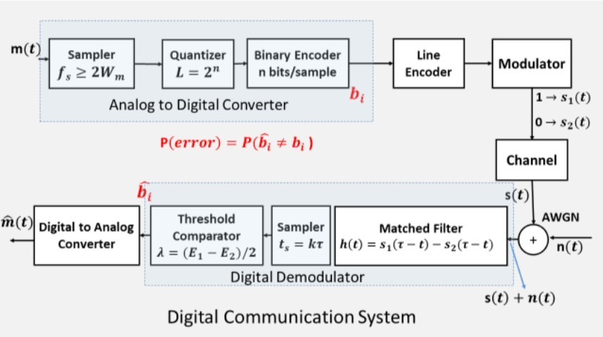

Figure 1: Digital*Communication*System [1]

Frequency-shift-keying is a digital-modulation technique where the-frequency of the modulated-signal-changes with-respect to the-digital-signal(message-signal). When the digital signal is-1, the frequency-of the-modulated signal is very-high. In-contrast, when-the-digital signal is-0, the frequency-of the-modulated signal-is lower. In-phase-shift keying, the modulated signal’s phase-changes when there-is a change in-the value of the digital-signal. When-the digital signal-changes from-0 to-1 or from 1-to 0, we see a change-in the-phase-while the-frequency and amplitude-remain-constant. In the figure-below, we-see the-modulated-carrier-signal-changes-its frequency in-accordance-with the-message-signal.[2].

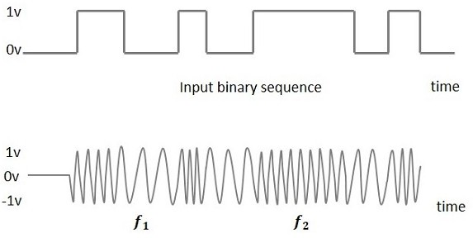

Figure 2: Frequency/Shift/Keying/Modulated output wave [3]

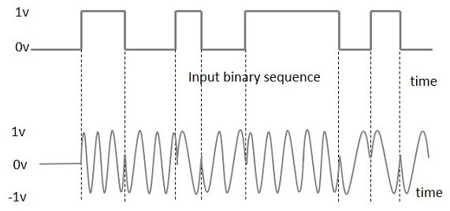

Figure 3: Phase/Shift/Keying/Modulated output wave [2]

There are two-types of shift-keying in-amplitude-shift keying, phase-shift keying and frequency-shift keying, which are hard-keying and soft-keying. In hard-keying the response-time is very-fast. In regards to-frequency and-phase shift-keying, when the digital-signal-changes-its value from-0 to 1, the change in-frequency or-phase happens-quickly unlike in-soft/keying, where the response-time-is small.[3].

## Frequency and Phase/Shift/Keying/Demodulation

The optimum-binary-receiver-can be done in-two ways, either-by using a matched-filter or a-correlator, which is a-multiplier followed by-an integrator. After that we-use a-threshold comparator-to set the-threshold. The-final-block is the-digital to-analog-convertor. The-bottom half-of Figure-1 shows the receiver-side in-digital-communications[1].

Equation-1 below, calculates-the threshold-by calculating-the energy-of the two-signals, subtracting-them, and-dividing by-two. Equation-2 is calculating-probability-of error-using the Q function due-to the-noise caused in-the-transmission. S1(t)/and/S2(t) are two-signals-and No/is the thermal-noise. Equation/3 is the-Energy-calculated for both-FSK and/PSK. Here 𝜏 is-the-bit duration[1].

Equation-1) Threshold-=-(E1-- E2) / 2 Equation-2)-Probability of-Error =

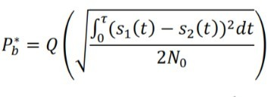

Equation-3)-Energy= ∫ S(t)^2 = ( A^2*𝜏 ) / 2 Equation-4) Bit-Rate-Rb = 1/𝜏

Equation-5) Bandwidth-for-PSK= 2Rb

Equation-6) Bandwidth-for-FSK = 2Rb+2ΔF

Using-the-threshold value, we can-compare the -value of the-sampler or-integrator output.-If the-value is below the-threshold then-zero is sent to the-DAC, and if-the value-is greater than-threshold, then-one is sent-to the-DAC.

# Procedure and Data Analysis

## Frequency shift*keying*Modulation

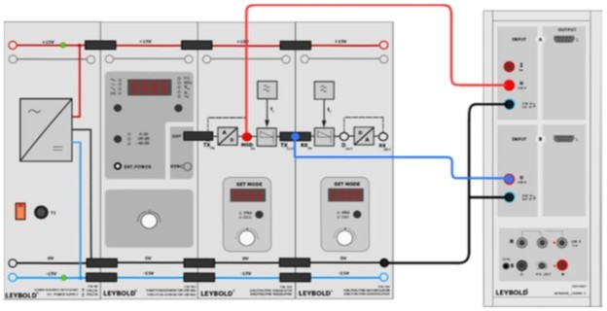

Figure 4: Frequency/Shift/Keying Setup [4]

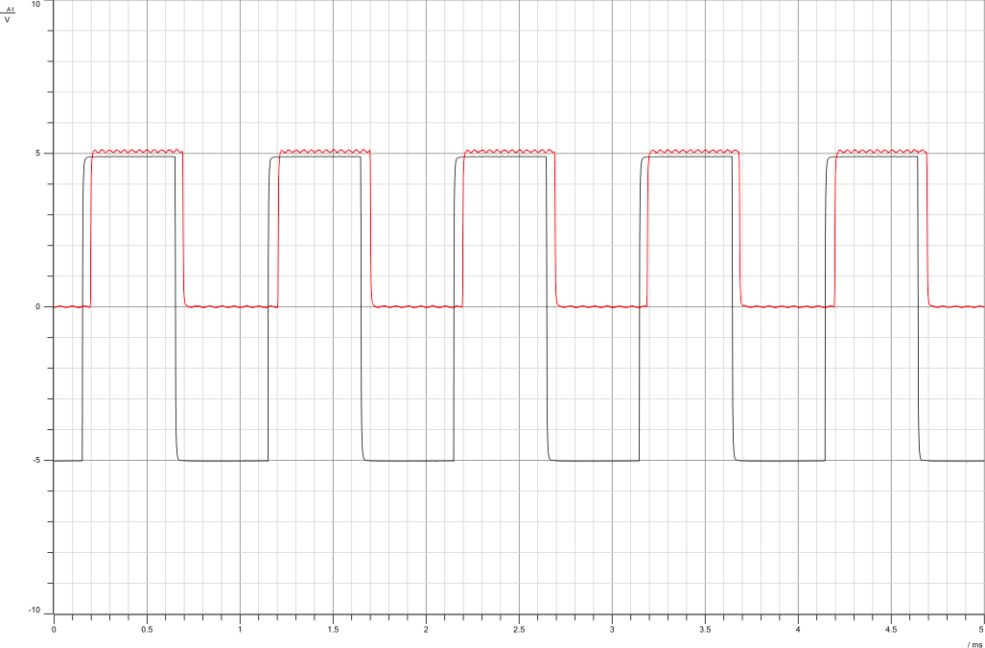First we-set the-function-generator to Square-wave, Freq= 1000 Hz, Vss= 10V, duty- cycle= 50%. Then-we set-the-modulator-mode to-DIG(digital). Select-Frequency-shift keying – Hard keying (F_1).

Figure 5: Modulating signal and/Unipolar square/wave signal(Hard Keying)

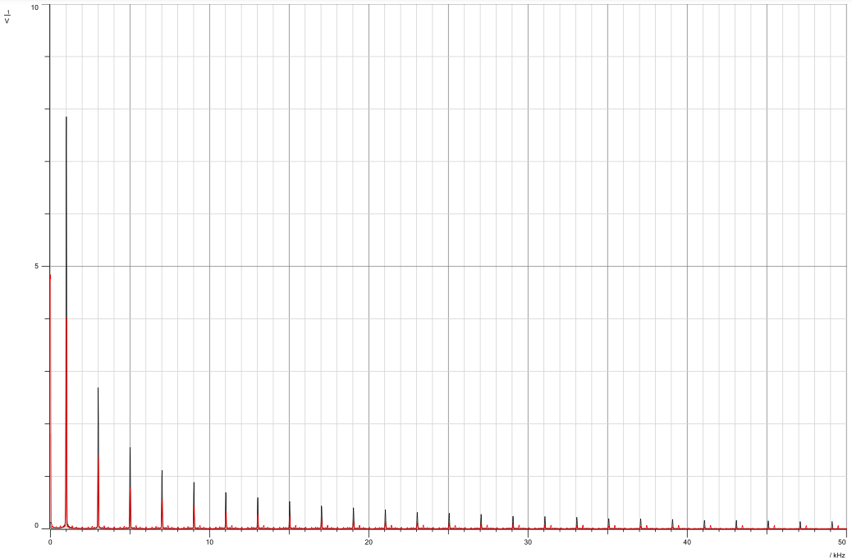

Figure 6: Modulating/signal and/Unipolar/square wave/signal in/Frequency/Domain

As can be- seen in the-figure above, we first-set up an-analog signal that-has an-amplitude of 5. This-signal is then-converted to-digital using th-analog to-digital block-in the-set. We-see now the-values are-either 0-or 1, this is-done using-the lin-encoding-unipolar-NRZ.

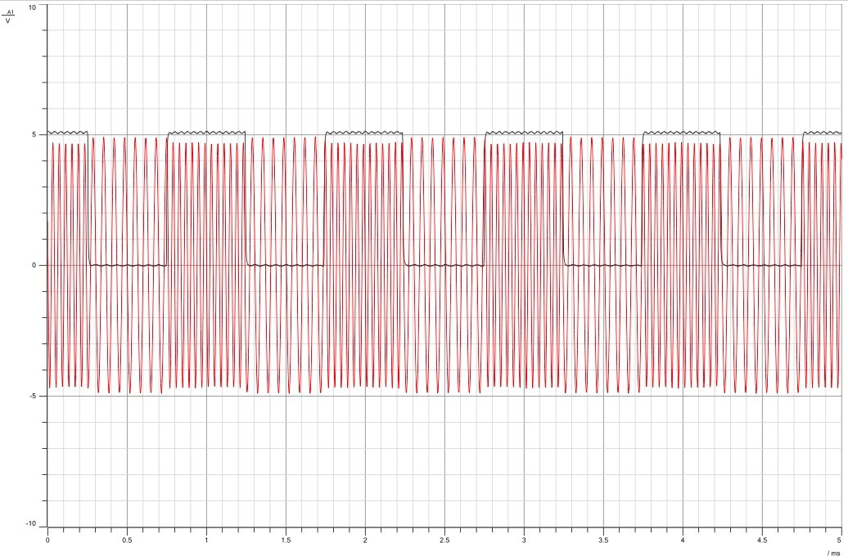

Figure 7: Unipolar square/wave signal and Modulated/Signal

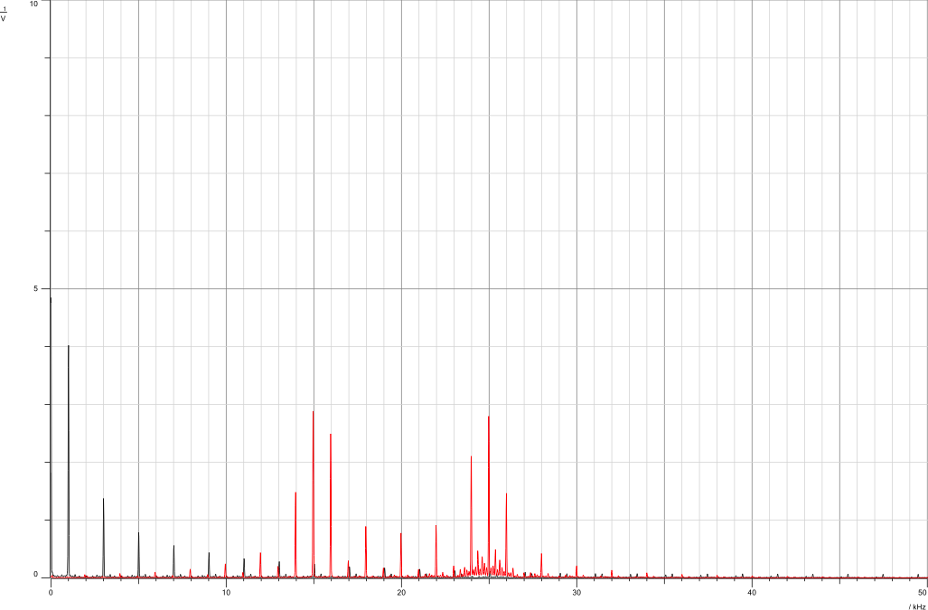

Figure 8: Unipolar square/wave signal and Modulated/Signal in Frequency/Domain

As in-Figure 7, the-frequency is-greater when-the digital-signal is-1, and when-the digital signal-is 0, the frequency-is lower. In figure-2 red-impulses represent the-2 envelope-sinc shaped functions-of the-modulated FSK-signal. Here the-frequency of-the carrier-signal is-20khz, and the-centers of-each envelope-sinc shaped-signals are-at 15khz-and 25khz, which-represent-

fc - (delta F), and fc+(delta F)-respectively.-Thus we-can conclude-that delta-F is equal-to 5khz.

In Figure-7, we can-see the change-in the frequency-of the carrier-signal as-soon as-the digital signal-changed values. This-change had a quick-response time-since we are-dealing with hard-keying. Now we-select the frequency-shift keying – soft-keying-(F_2) and-see the difference-in the-response time.

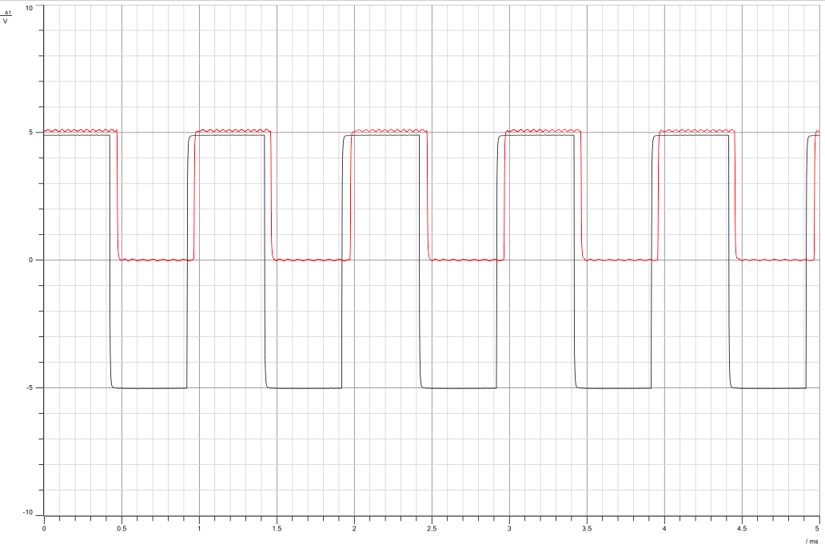

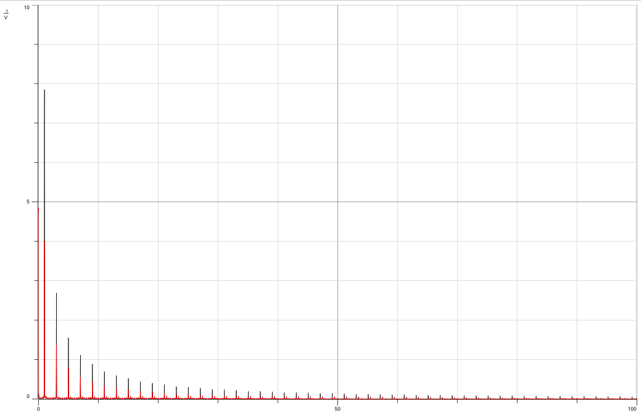Figure 9: Modulating/signal and Unipolar/square wave/signal(Soft Keying)

Figure 10: Modulating/signal and Unipolar/square wave/signal in/Frequency Domain(Soft Keying)

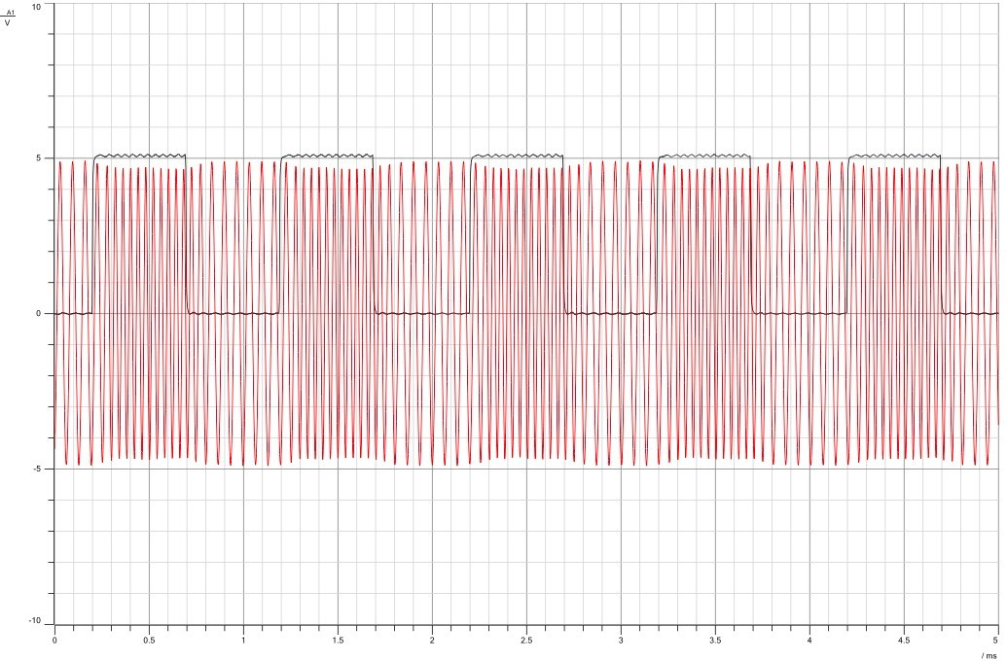

Figure 11: Unipolar/square wave signal/and Modulated/Signal(Soft Keying)

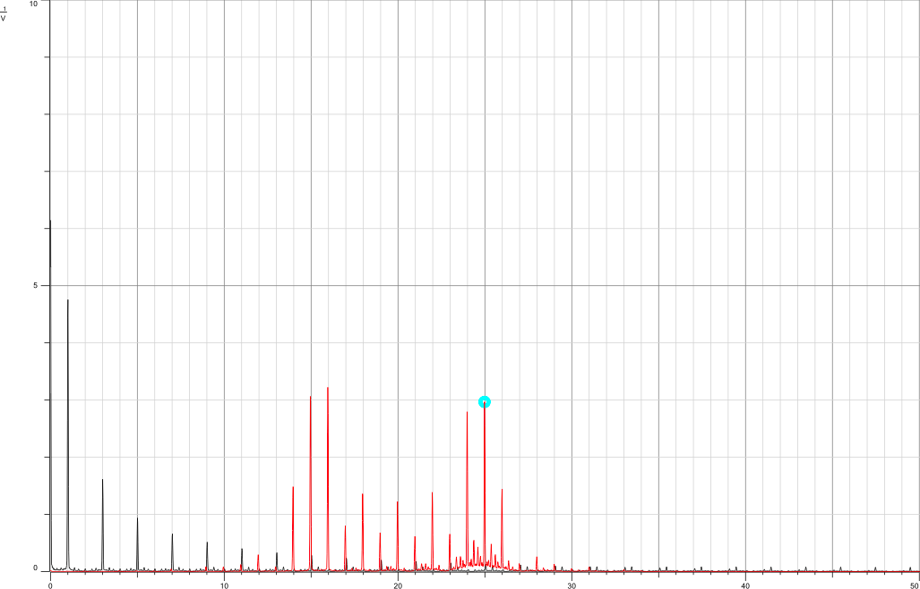

Figure 12: Unipolar/square wave signal/and Modulated/Signal in/Frequency/Domain (Soft Keying)

Soft-and-Hard keying-does not-affect the signal- in the frequency-domain. It-affects the response-time, which-can be-seen in the-time domain-in both-ASK and-FSK.

Let's explore the impact of altering the message signal's amplitude. As outlined in the theory section, the DAC's output hinges on the threshold's determination. In this context, the upper threshold stands at 2.3, while the lower threshold rests at 1.67. Consequently, if the signal's Amplitude falls below 2.3, it transmits the value 0; surpassing 2.3 prompts a transmission of the value 1. For our specific kits, the 0 binary value corresponds to a frequency of 15kHz, while the 1 binary value aligns with 25kHz. In the diagram below, we've decreased the message signal's amplitude to 2v-(Vss=4). Consequently, as the amplitude dips below the threshold, the impulse shifts to 15kHz instead of the anticipated 25kHz.

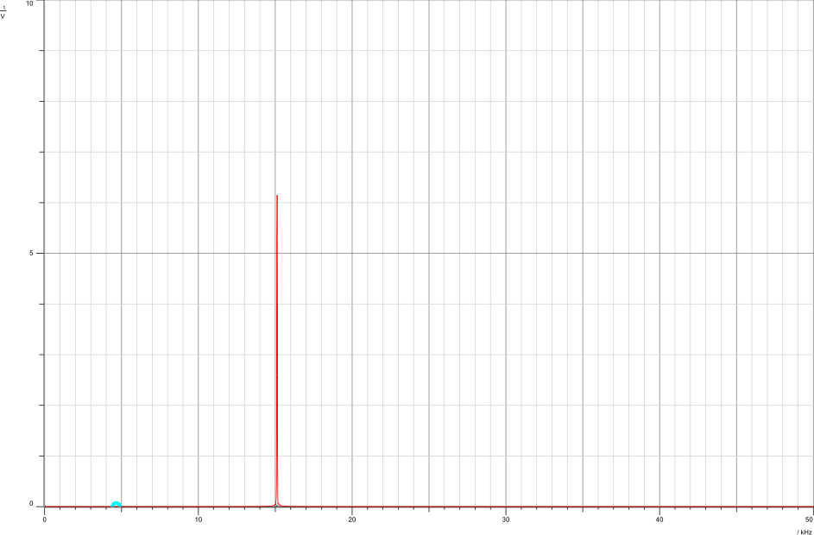

Figure 13: Signal sent/at binary/value 0, with/frequency/15khz

Now we-will study-the effect of-changing the-frequency of the-message signal. We set the-function generator-to the following: Square-wave, Freq = 500 Hz, Vss = 10V, duty-cycle = 50%.

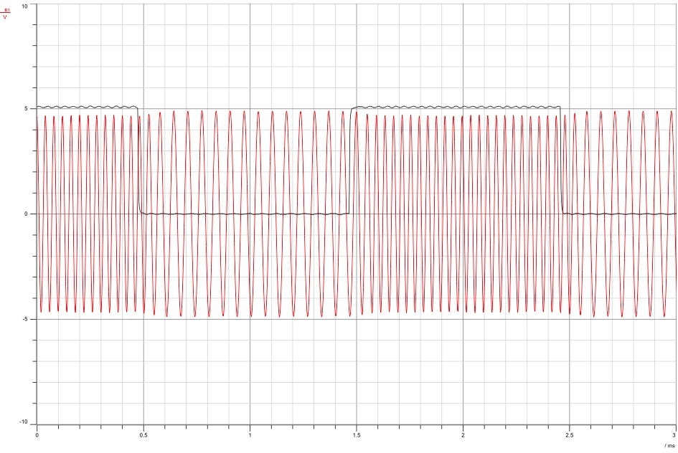

Figure 14: Unipolar/signal and/Frequency Shift/Keying/signal/with fm=500hz

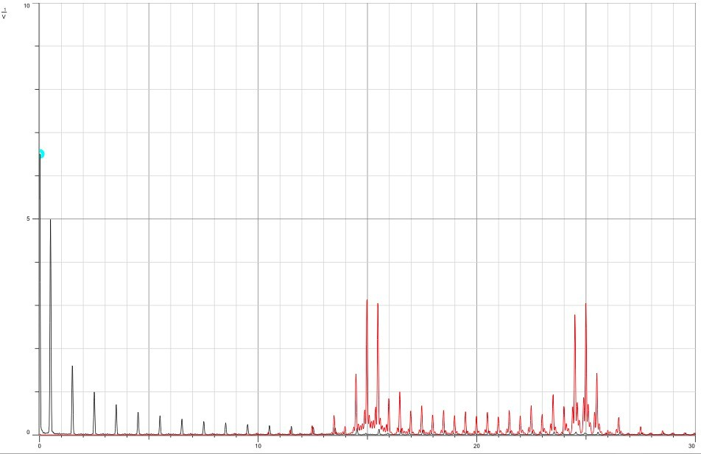

Figure 15: Unipolar/signal and/Frequency/Shift Keying signal/with fm=500 hz in Frequency/Domain

The frequency domain illustrates the message signal's frequency at 500Hz. Notably, as we decrease the frequency from 1kHz to 500Hz, there's a discernible increase in the number of impulses concentrated around the centers of the enveloped sinc-shaped signals.

Let's explore the impact of adjusting the duty-cycle. When we set the duty-cycle to 10%, we observe in the frequency-domain that the impulse-at the lower-frequency gains more emphasis-compared to the impulse-at the higher-frequency. However, with a duty-cycle of 50%, both centers receive equal-emphasis, as depicted in the figures-below.

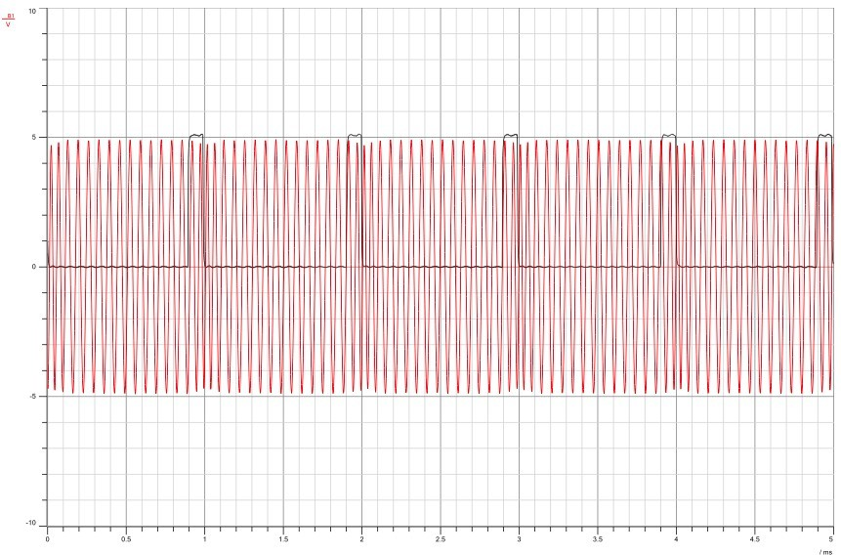

Figure 16: Signals/with/duty/cycle 10%

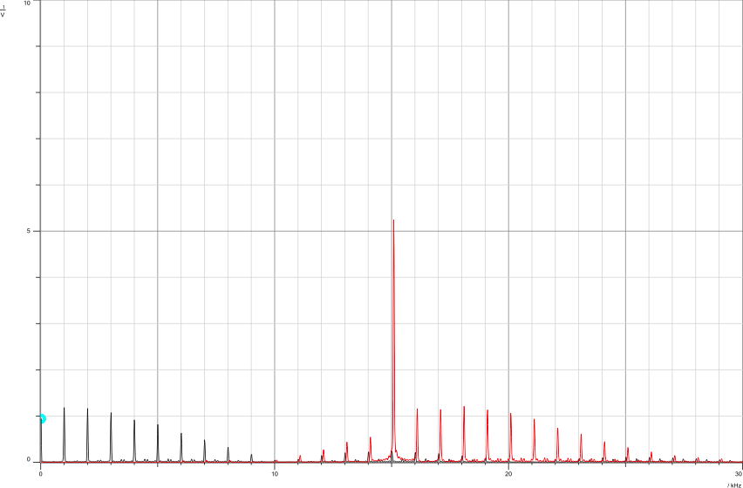

Figure 17: Signals/with/duty/cycle 10% in Frequency/Domain

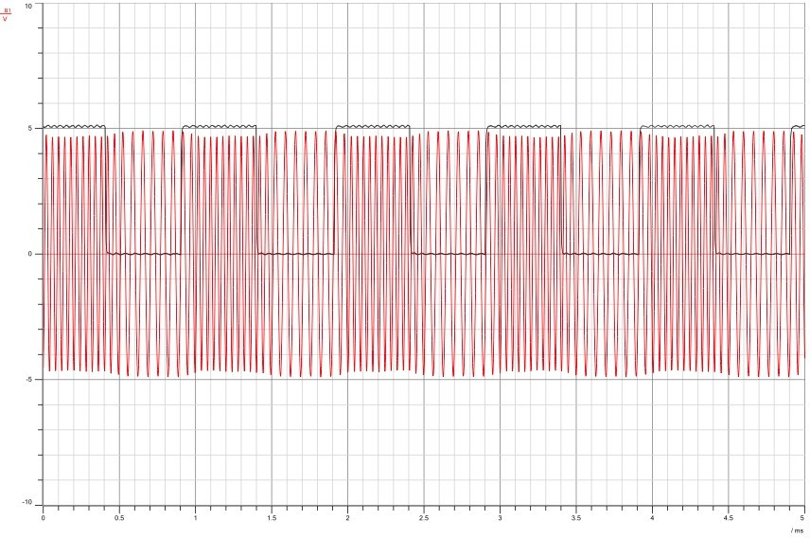

Figure 18: Signals/with/duty/cycle 50%

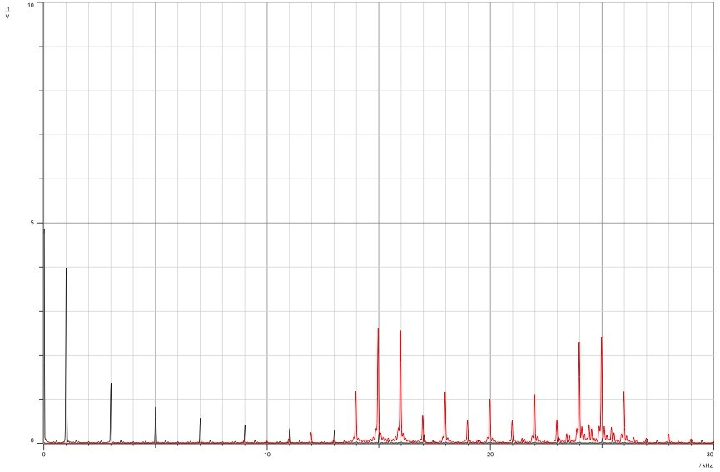

Figure 19: Signals with/duty/cycle 50% in/frequency/Domain

## Frequency shift*keying*Demodulation

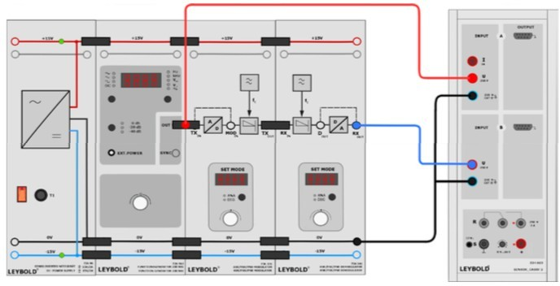

Figure 20: Frequency Shift/Keying/Demodulation/Setup [4]

You've set the function-generator with the following-configurations: Square-wave, Frequency= 1000-Hz, Vss= 10V, and a duty-cycle of 50%. Additionally, you've selected the demodulator-mode as-Digital (DIG) and opted for-demodulation type (F).

In the-figures below, we can-see the bipolar-message signal-with amplitude-5 and the demodulated-signal. In the frequency-domain, the demodulated-signal has successfully-retrieved the message-signal with the same-frequency. However, in the time-domain-figures, we can-see that the-2 signals-dont perfectly-align with one-another, there is a-small shift.-In theory, the demodulation-process is ideal-and retrieves-the exact-message signal in its-exact form. However, in practical-implementation it is-difficult to have-the two signals-align perfectly-on top of each-other because-there is always-some kind of-interference and-noise. This imperfection-can also be caused-by filter-characteristics as there-is no ideal-filter-practically achieved.

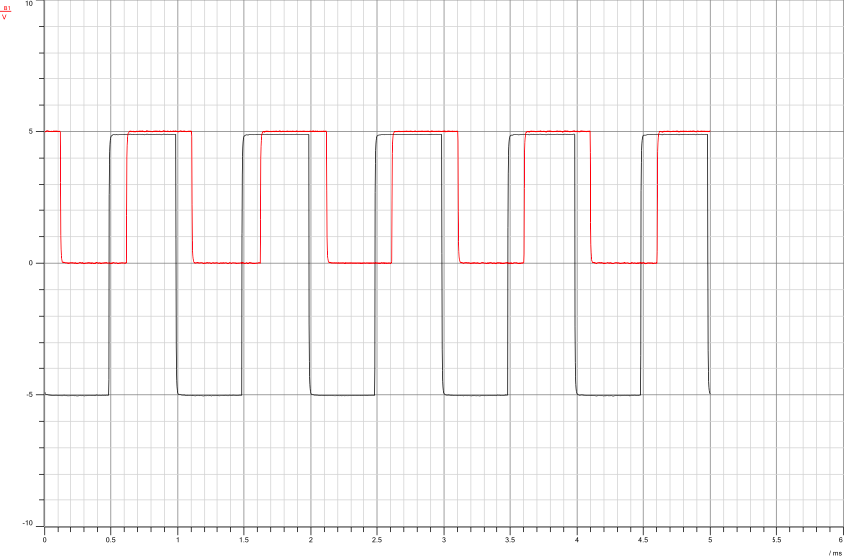

Figure 21: Bipolar/message and demodulated/signals in/Time Domain (Hard keying)

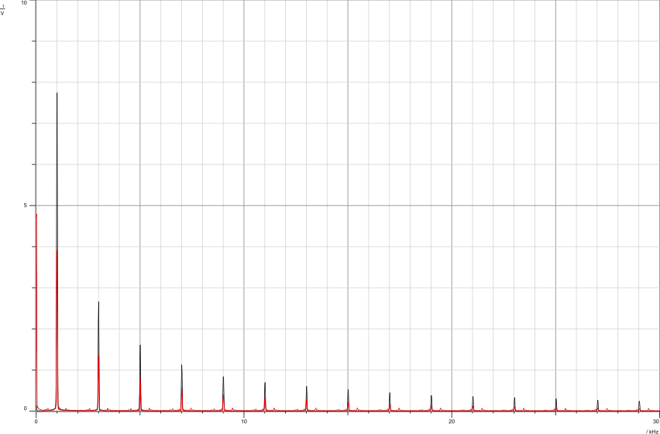

Figure 22: Bipolar/message and demodulated/signals in/Frequency Domain (Hard keying)

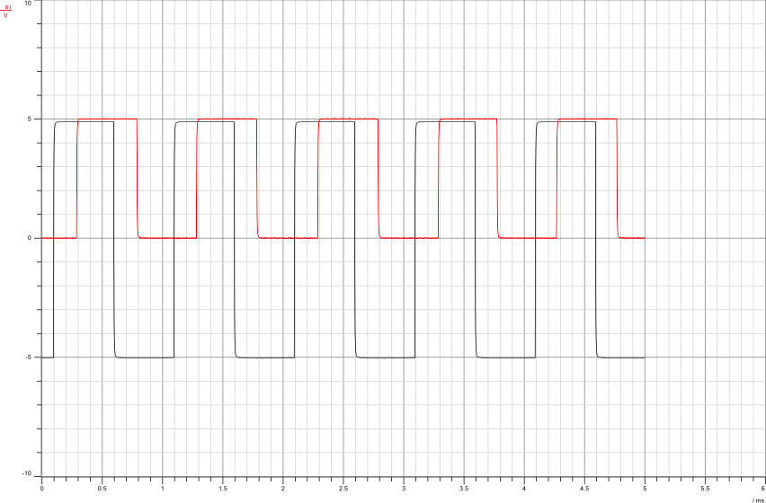

Figure 23: Bipolar/message and demodulated/signals in/Time Domain (Soft keying)

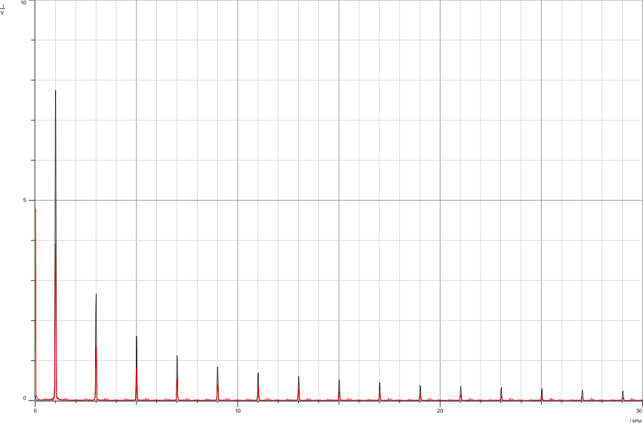

Figure 24: Bipolar message and demodulated signals in Frequency/Domain/(Soft Keying)

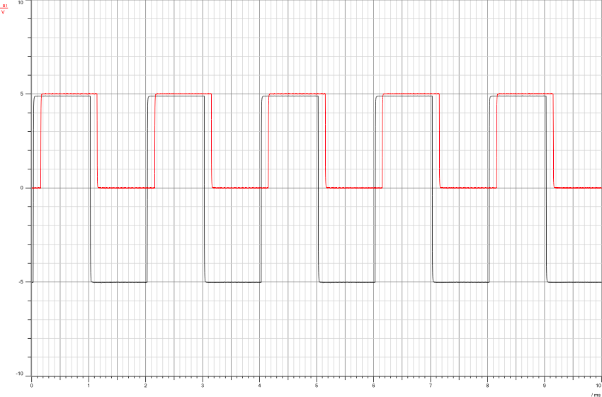

Figure 25: Bipolar message demodulated signals in Time/Domain with fm=500hz

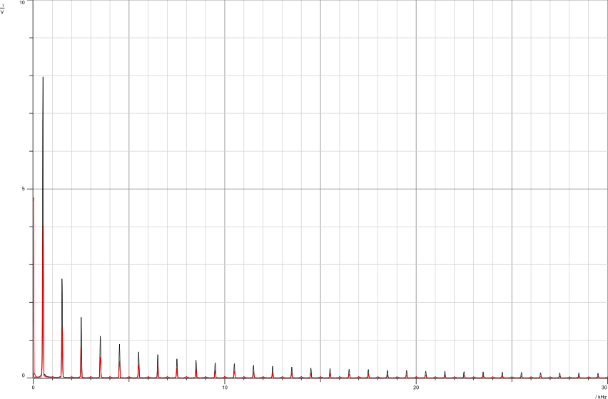

Figure 26: Bipolar message and demodulated signals in Frequency/Domain with fm=500hz

When-changing the message-frequency from 1khz to-500hz, the-number of-impulses in the-frequency domain-increases because now-there is an impulse-every 500hz. We can-also see the demodulated-signal is closer to the message-signal when it has a-smaller-frequency.

## Phase shift*keying*Modulation

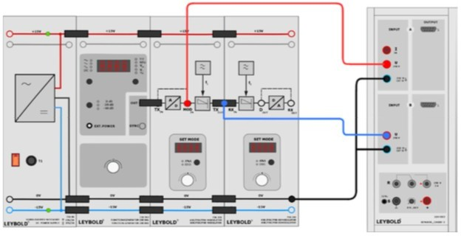

Figure 27: Phase shift keying/Modulation Setup [4]

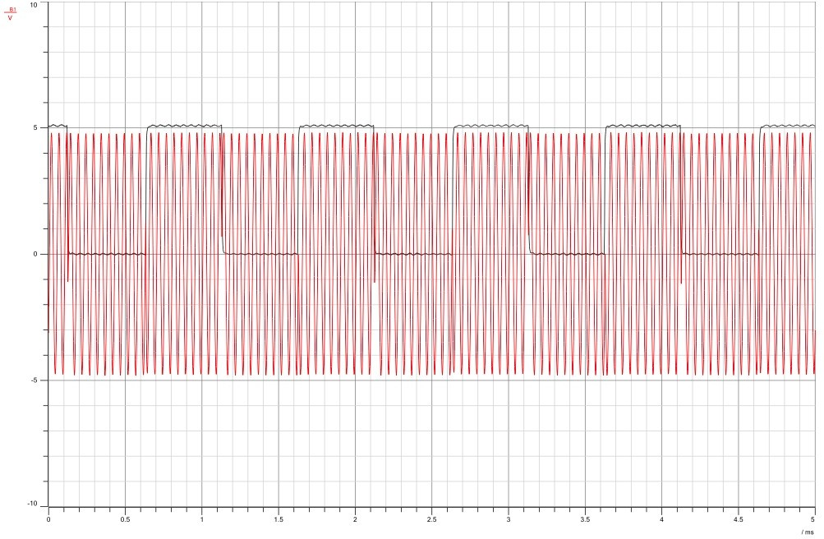First we-Set the function-generator to the following-settings: Square-wave, Freq = 1000 Hz, Vss = 10V, duty-cycle = 50%. Then,-Set the modulator-mode to-Digital (DIG). Select-Phase shift-keying – Hard-keying(P_1).

Figure 28: Unipolar/signal and Phase/Shift Keying/Signal/(Hard Keying)

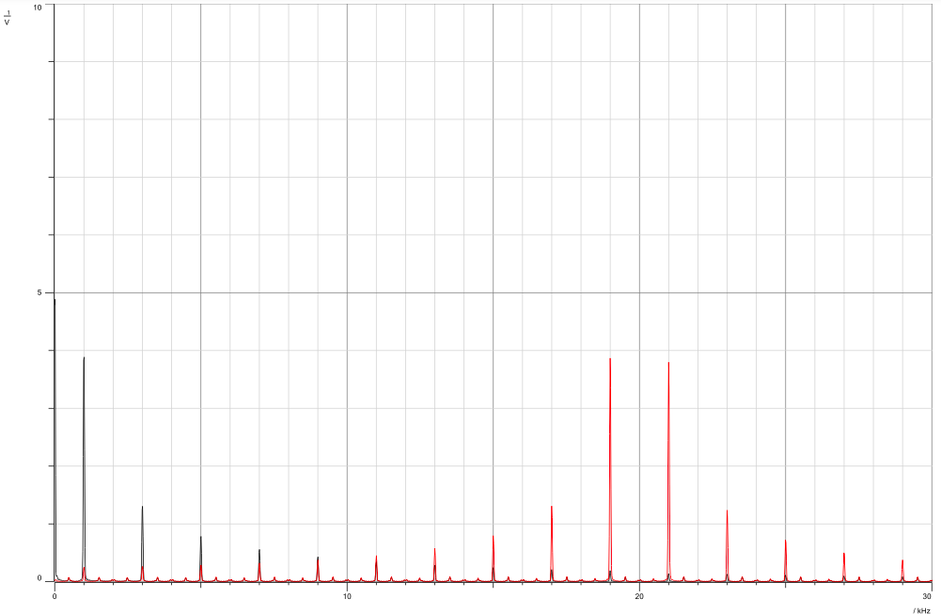

Figure 29: Unipolar/signal and Phase/Shift Keying/Signal in Frequency/Domain (Hard Keying)

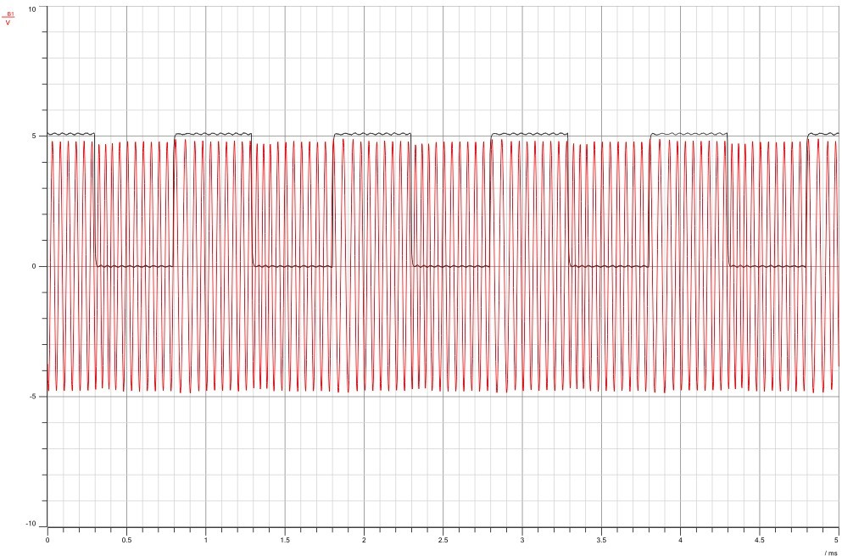

Figure 30: Unipolar/signal and/Phase Shift/Keying/Signal (Soft Keying)

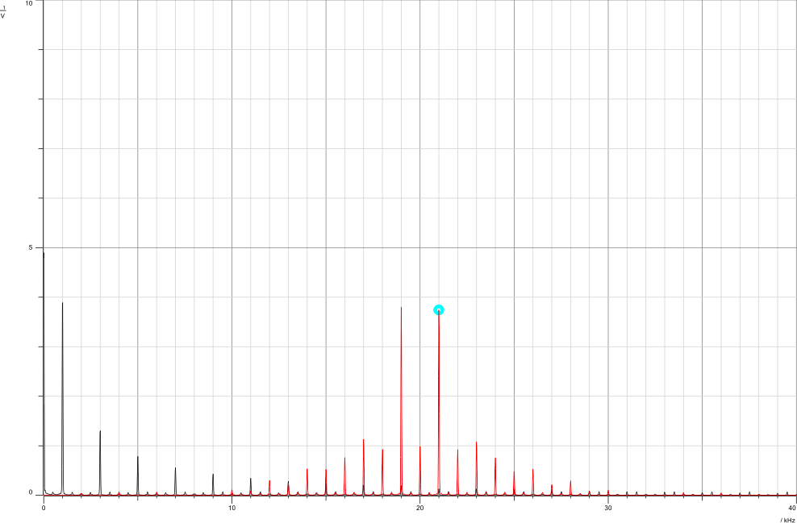

Figure 31: Unipolar/signal and/Phase Shift/Keying Signal in/Frequency/Domain (Soft Keying)

As can-be seen in-the figures-below, the change-happens in the-phase of 180-degrees when the digital-value changes-from zero-to one or-from one to-zero. In hard keying-the change happens-fast as seen in-figure 28, while in-figure 30 the-change happens-slower.

We can-see the modulated-signal in-the frequency-domain-consists of-multiple-impulses all around the-frequency of the-carrier, its envelope-shaped like a sinc-function. The first-Null point that-crosses the zero-should be at-fc+(1/∆) and fc-(1/∆). Calculating-the-bandwidth would give a-result =-fc+(1/∆)/--/(fc-(1/∆))*=*2Rb*=*2*bitRate.

Now we will-see the effect-of changing the-message signal’s-amplitude of the-modulated signal. We-reduce the message-signal amplitude to-2v(Vss = 4v).

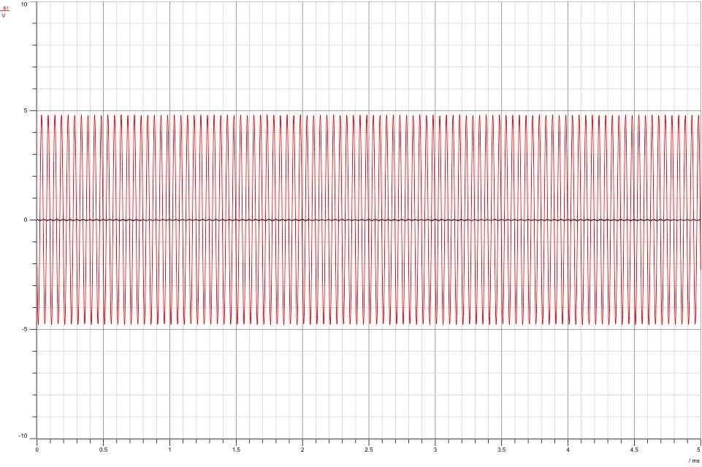

Figure 32: Phase/Shift/Keying signal/with Am=2V

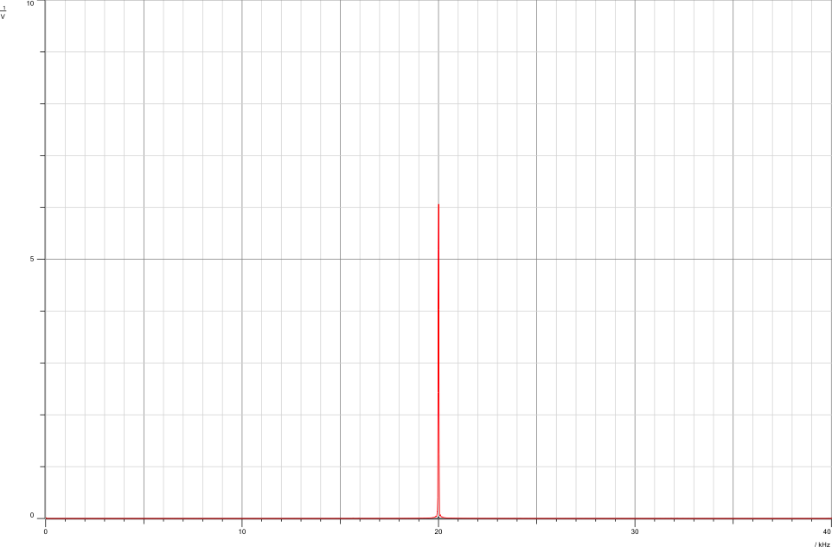

Figure 33: Phase/Shift/Keying Signal/with Am=2V in frequency/domain

From the-figures-above, we realize-that changing-the message-amplitude has no-effect on PSK-signal. The spectrum-stays at 20 khz-since-changing the-amplitude or-frequency of-the message signal-wont show-on the-phase.

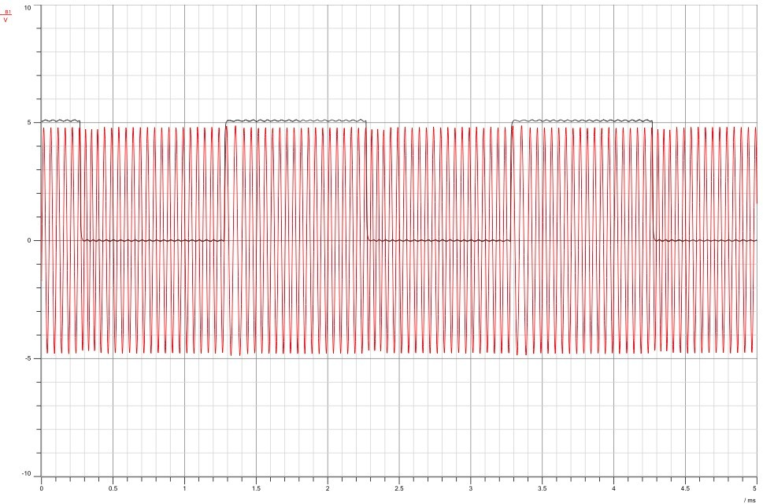

Figure 34: Phase/Shift/Keying Signal/with fm = 500hz

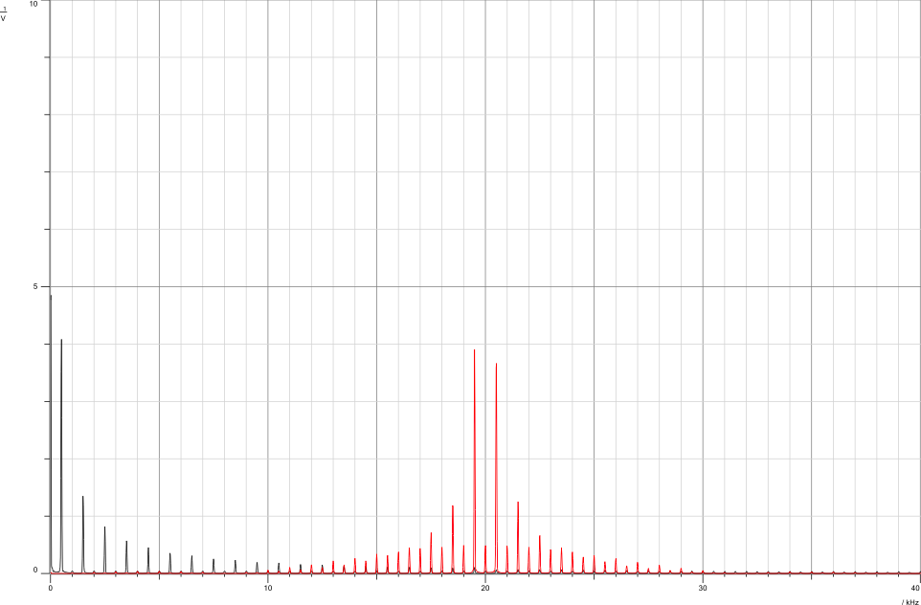

Figure 35: Phase Shift/Keying/Signal with/fm = 500hz in Frequency/Domain

As seen in the-figures-above, changing-the frequency of th- message signal-will-increase the number of-impulses for the modulated-signal PSK. Now we will-see the effect-of changing the duty-cycle on the-modulated signal-by changing-the duty-cycle to 10%. In the-figure below, we-can see the impulse-at the carrier with-frequency 20 khz-is greatly emphasized-compared-to figure 35.

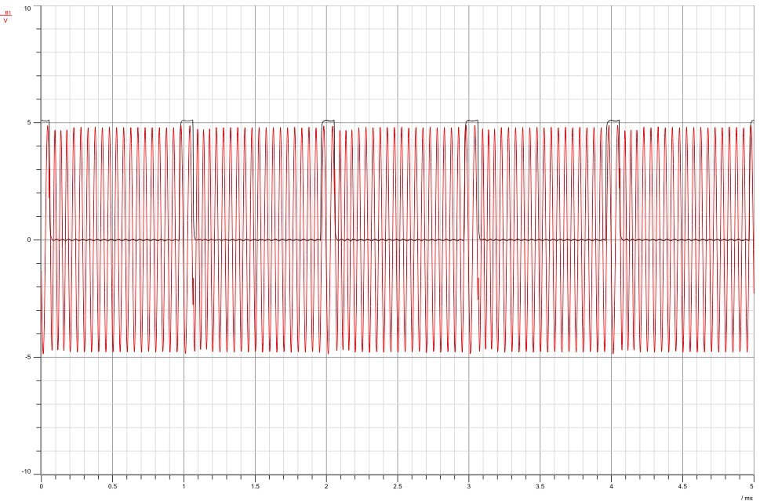

Figure 36: Phase Shift/Keying/Signal with/duty cycle 10%

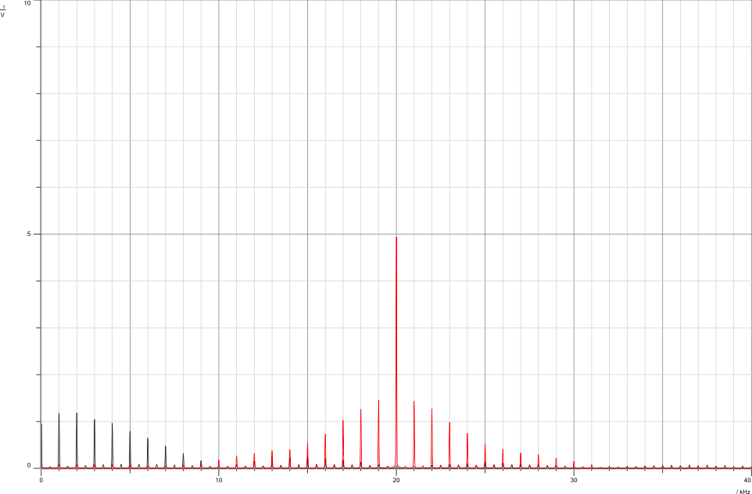

Figure 37: Phase Shift Keying Signal with duty cycle 10% in/Frequency/Domain.

## 3.4 Phase shift*keying*Demodulation

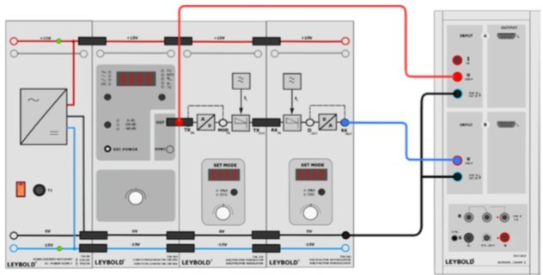

Figure 38: Phase Shift/Keying/Demodulation/Setup [4]

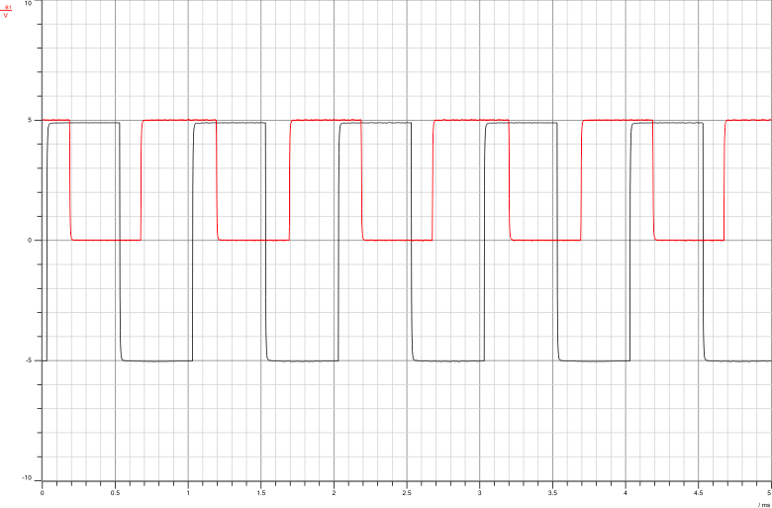First Set-the function-generator to the following-settings: Square-wave, Freq = 1000-Hz, Vss= 10V, duty-cycle= 50%. Set the-demodulator-mode to-Digital (DIG). Select the demodulation-type (P_1). We must-make-sure to set the-modulator mode-to Digital-(DIG) AND Select-Phase-shift keying – Hard keying (P_1).

Figure 39: Message and Demodulated Signals/(Hard Keying)

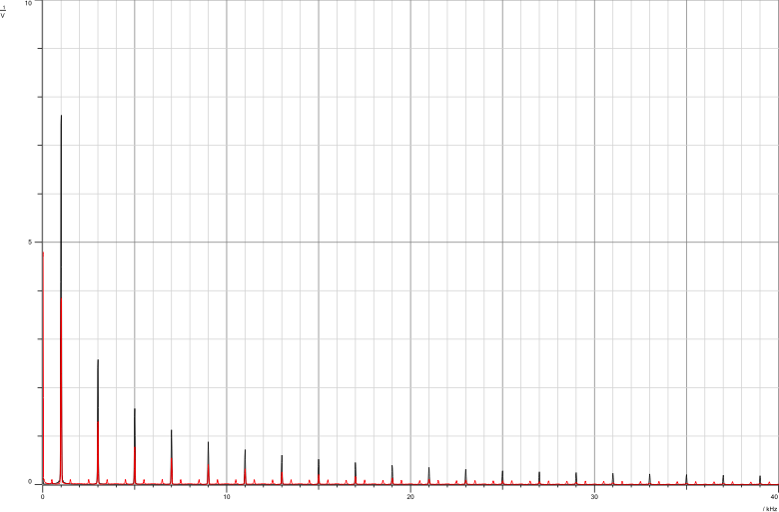

Figure 40: Message and Demodulated Signals in Frequency/Domain/(Hard Keying)

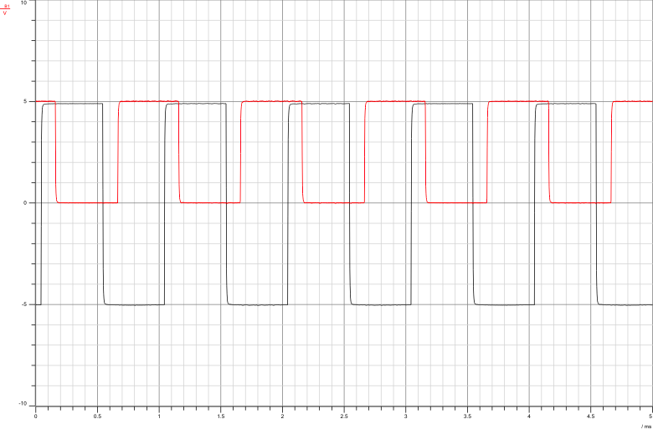

Figure 41: Message and Demodulated Signals/(Soft Keying)

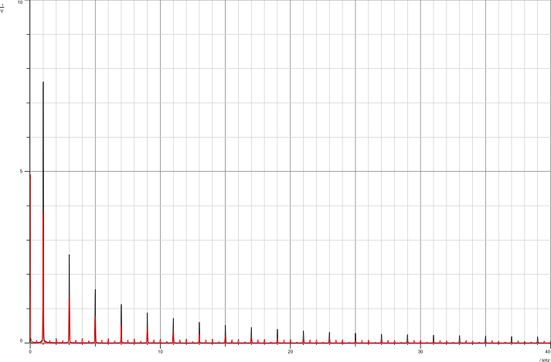

Figure 42: Message and Demodulated Signals in Frequency/Domain/(Soft Keying)

The pictures for hard-keying and soft-keying display the demodulated signal a bit shifted compared to the message-signal. This happens because there's interference and noise sneaking in. So, the signal we get back has both the message we want and some unwanted noise. But when we look at the frequency parts for both hard and soft-keying, we notice that the signal we get back still has the same message frequency as the original one..

The difference in phase shown in the figures between the demodulated-signal and the message-signal might not only be because of noise and interference. It could also be linked to how the filters work or flaws in the circuits of the-modulation and-demodulation kits we used in the lab. In a perfect-setup, these two signals should have the same-phase-shift, but that's not always the case in real-life setups due to these factors.

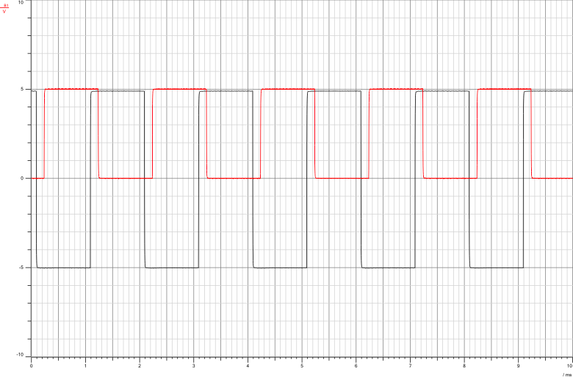

Figure 43: Message and Demodulated Signals/with/fm=500hz

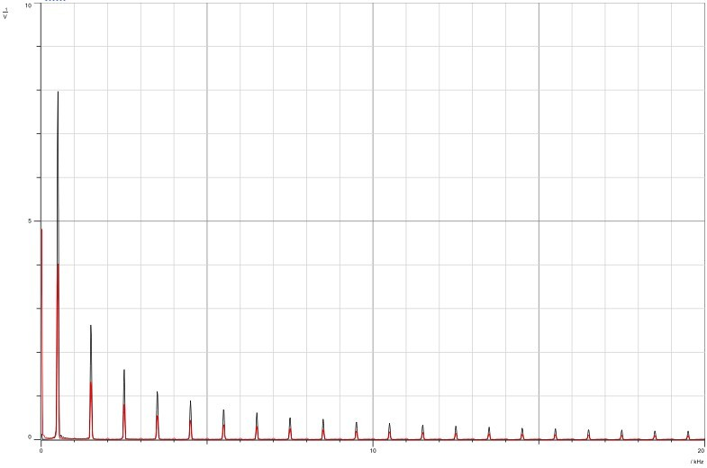

Figure 44: Message and Demodulated Signals/with fm= 500hz in/Frequency/Domain

As can be-seen in the-figure-above, the demodulated-signal still has a phase-shift compared to the message-signal. The demodulation-process did succeed in-retrieving the message-signal with the same-frequency but with noise-interference. Changing-the-frequency of the message-signal-frequency from-1khz to 500hz increased the-number of spectral-lines. In figure-42 we see 5-spectral lines from 0 to 10khz; however, in figure-44, we see-10 spectral-lines from-0 to-10khz.

# Conclusion

In this lab, we dived into Frequency Shift-Keying and Phase-Shift-Keying, going deep into their workings. Our experiments vividly highlighted the contrast between soft and hard-keying. We explored how the message signal's-amplitude, frequency,-and duty-cycle influence both the time and frequency-domains of the modulated-signal. Additionally, we delved into the receiver's role (demodulation)-and emphasized the-significance of the threshold-comparator in this-process.

# References

1. : Dr.Wael-Hashlamoun-Communications-Slides
2. :https://[www.tutorialspoint.com/digital_communication/](http://www.tutorialspoint.com/digital_communication/)digital_communication_phase_shift_keying.htm…[Accessed 18 Dec. 2023, 13:22]
3. :https://[www.tutorialspoint.com/digital_communication/](http://www.tutorialspoint.com/digital_communication/)digital_communication_frequency_shift_keying.htm…[Accessed 19 Dec.2023, 14:02]
4. : Communication lab manual version 3 [Accessed 19 Dec.2023, 19:21]